Training Name : NUnit, Jasmine, Karma
Name : Rikin Patel

Q.1 : Write brief description about unit testing and functional testing and its benefit as developer perspective?
Ans -
Unit Testing : Unit testing is a type of software testing where individual units or components are tested, which helps to eliminate the risk of having a bug in codes.
Unit testing is performed by the developer during the development cycle.
The goal of unit testing is to break each part of the source code into the unit and check that each part works properly. It means that if any set of input is not functional, it should return an expected output.
Functional Testing : Functional testing is performed by the tester during the level of system testing. The purpose of Functional testing is to test each functionality of the software application, by providing approprieate input, and testing output according to that.
Benifit of unit testing :
- isolate and verify a section of code
- test every function of code
- find errors and bugs in development cycle only
- allows developer to understand a section of code, refine that code and make sure that module works properly.
- enables testing parts of the project without the dependancy of other modules
Benifit of Functional testing :
- finding errors that developer may have missed during development
- provide information about the quality of program
- evaluation of the functionality and performance of the application before released

Q.2 : Where and why are you needed unit testing in your project, give me 10 example and code snap.
Ans : Below is the unit testing methods I have used for my past projects, I have described the project name and the task of the methos which I have tested.
1. Passenger management app – getting the list of passengers
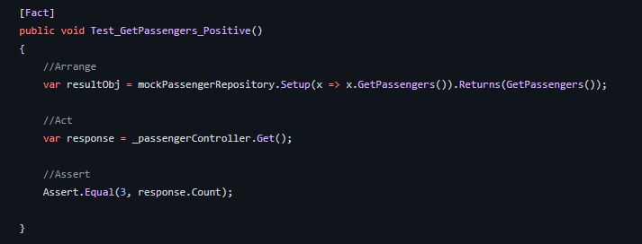
2. Passenger management app – Adding a passenger
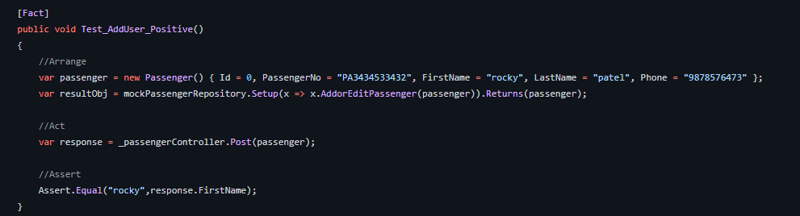
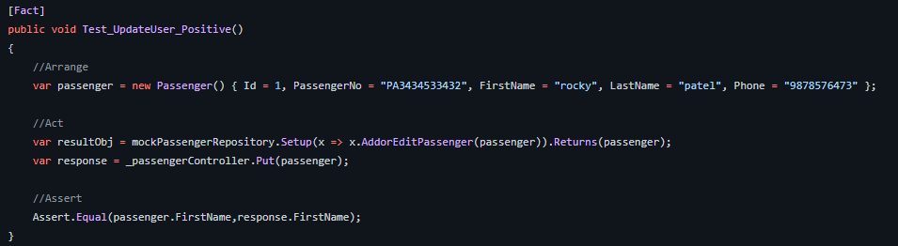
3. Passenger management app – Updating a passenger
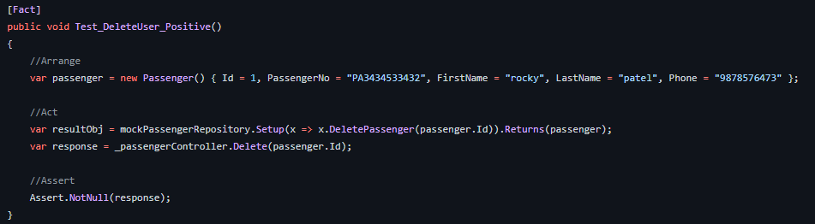
4 . Passenger management app – Deleting a passenger
5 . String operation app – Change case of string
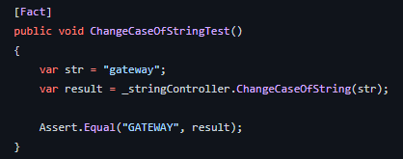

6. String operation app – Change case of every character
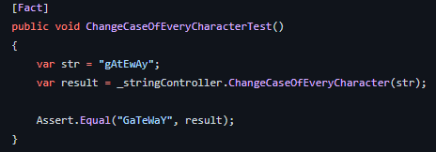

7. String operation app – Change to title case
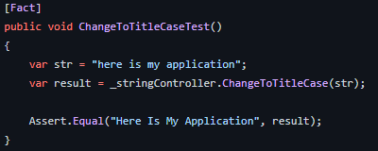

8 . String operation app – Capitalize the string
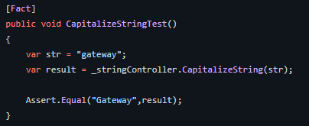

9.String operation app – Check if string is numerical
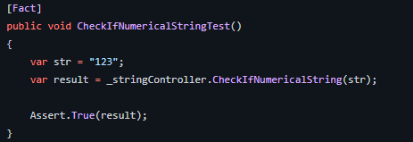

10 .String operation app – Get word count
